Message from the Principal  April is a special Awareness Month at PS 225. We celebrate Earth Day this month, a day to reflect on our role as partners with the planet. It's time to act boldly, be innovative and implement steps to restore and preserve our natural resources. I encourage you to enjoy the beauty of nature, spend time with children outside. Try to recycle and upcycle (turning old products into something new) so we can maintain our earth for generations to come. Also, this month, we celebrate Autism Awareness. Throughout the month we will focus on sharing stories and providing opportunities to increase understanding and accepting of people with autism.  I am also very excited to promote the return to in-person parent events. For both the May and June PTA meetings, we will be inviting vaccinated family members to attend meetings in our school- and each month with have a special event attached to it. Get ready to play board games and read bedtime stories with your children, the PTA and staff volunteers. We will continue to live stream our PTA meetings so all may join virtually but hope you will consider attending our in-person events. (COVID Vaccine regulations will be in effect for all adult participants.). More details will be shared at our April PTA meeting.  And on a final note, this is a call for volunteers. Our PTA needs you! If you are interested in becoming a member of one of our PTA committees, or, if you are interested in running for office, please reach out to Millie or Ms. Mejias for more information | Monday | Tuesday | Wednesday | Thursday |  | Friday
 | Autism Awareness Month | Please visit our school website https://www.ps225k.org/  Follow us on Instagram  @225publicschool  Follow us on Twitter  Official PS225 (@ps225k) / Twitter |  |  |  | 4/1  Poetry day
 | 4/4 | 4/5 | 4/6  PTA Spring Sale  School Spirit – Wear your school colors | 4/7  PTA Spring Sale |  | 4/8  PTA Spring Sale
 | 4/11 | 4/12  PTA Spring Sale | 4/13  PTA Spring Sale  Silly Hair Day - How silly can you wear your hair | 4/14  PTA Spring Sale  Earth Day |  | 4/15  No School  Spring Recess
 | 4/18  No School  Spring Recess | 4/19  No School  Spring Recess | 4/20  No School  Spring Recess | 4/21  No School  Spring Recess |  | 4/22  No School  Spring Recess
 | 4/25  Autism Awareness Day | 4/26  Math Exam | 4/27  Math Exam | 4/28  Math Exam Make-ups  PTA meeting & elections |  | 4/29  Poem in your pocket day
 | Reminders:  PTA Snack Shack  Every Tues, Wed, Fri  All items are $1 | Public School 225  The Eileen E. Zaglin School  1075 Oceanview Avenue  Brooklyn NY 11234  718 743-9793  718 743-7096 Fax | Administration  Susan Barone – Principal  Dr. Barbara Pelegrinis – Asst. Principal (3-8)  Gina Pluviose – Asst. Principal (Pre -K – 2)  Christine Monfasani – (Special Ed & ENL)  Parent Coordinator Anita Mejias  amejias@schools.nyc.gov x2024 |  | PTA  Milagros Martinez – President  Jahaira Maldonado – Secretary  Nicole Harchuck – Treasurer  PTA Email 21k225pa@schools.nyc.gov
April Events
April 1 | April 6 | April 13 | April 14 | April 25 | April 29
Poetry day  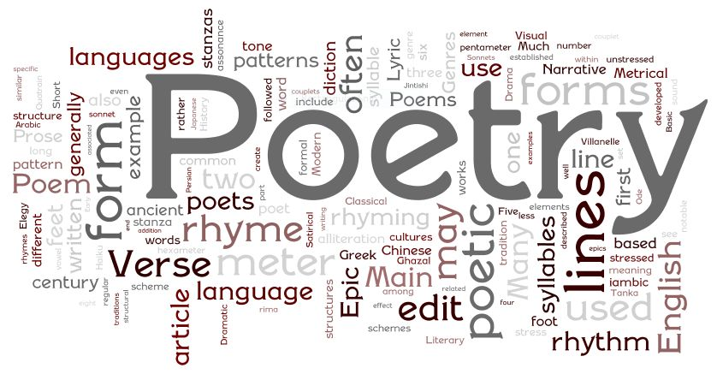 | School spirit day    Wear your school colors | Silly Hair Day  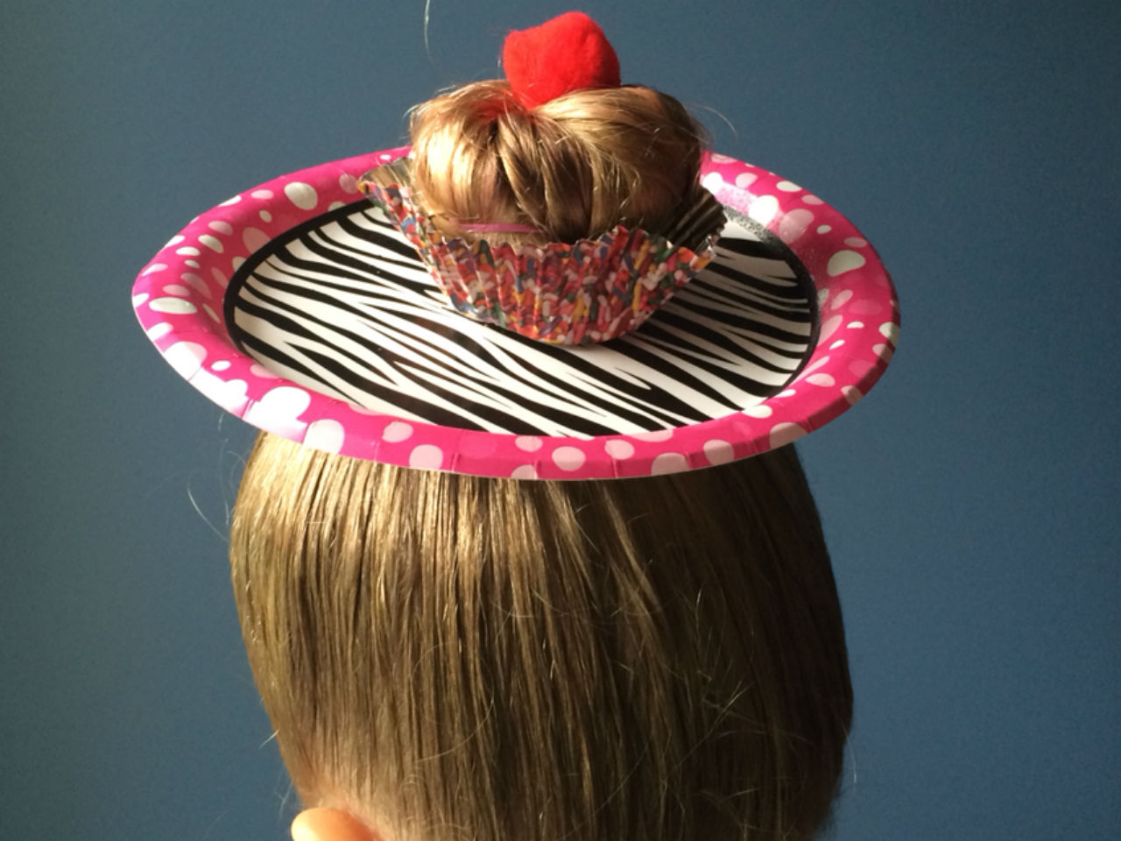  How silly can you wear your hair | Earth Day   | Autism Awareness Day   | Poem in your pocket day  

